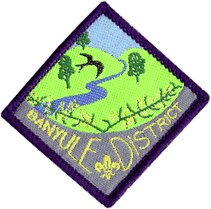
Banyule District Cubs
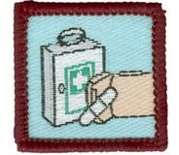
Formerly Red Level 2
First Aid Course
Saturday 27th May & Sunday 28th May
1st Ivanhoe Scout Hall
49 Hawker St Ivanhoe
Cost: $30 per Cub (includes 2 lunches and 1 dinner)
Eligibility: Cubs who haven’t done the course and are due to go up to Scouts
by end of June 2024.
Wear: Full uniform
Saturday: Arrive well before 11-00am (need to have time to sign in).
Finish: 7-30pm.
Sunday: Arrive well before 9-30am. Finished by 2pm
Cubs need to be signed in and parents to leave a contact number for both days.

All Cubs MUST bring a small personal First Aid kit on the Sunday morning (should be put together by the Cub). See your Akela for details about this. It should be fitted in a small container.
Saturday will consist of training in a wide range of aspects of First Aid, along with breaks for some fun. There is one more training session on Sunday (First Aid kits) before we get into the testing session. In addition to a written multiple choice test, Cubs will be paired up and tested across a number of different scenarios where they will treat the ‘victim’ for the problems they find.
If your child needs to be absent for a small part of the weekend, could you please write on the form the time they will be not be attending.

Please advise of dietary requirements.

Return to your Akela (Cub Scout Leader ) at the latest, Tuesday 23rd May
Banyule District Cub First Aid Weekend:
Cub Name.............................................. Pack.....................................
Dietary requirements..........................................................................
Will be absent from the Course? (When?).......................................................
Payment methods:
Via EFT,
Banking details
Banyule District Cub Scouts
The BSB is 633 000 ( Bendigo )
A/C 152262291.
Reference : Name, Group & event – e.g. Mary Jones – Rosanna Cubs – First Aid
Cash payable on the day
Signed..................................... Phone No...................................

Any questions,
Pete Owens
DLCS Banyule
Mb 0408 323 083
Em: peter_d_owens@bigpond.com.au

